**Lab No.09**

01. Write a function that prints all the unique values from an array and the number of times each value occurred. The main function takes a size of array as input and generates a random integer array with name **“array1”**. Random number limit must be between 0 and 10. The ‘main’ function calls a function with the name as “CountFrequency( )” that will find the occurrence of each value in array.

#include <stdio.h>

#include <stdlib.h>

void CountFrequency(int array[], int size) {

int frequency[20] = {0};

for (int i = 0; i < size; ++i) {

frequency[array[i]]++;

}

printf("Unique values and their frequencies:\n");

for (int i = 0; i < 20; ++i) {

if (frequency[i] > 0) {

printf("%d occurred %d times\n", i, frequency[i]);

}

}

}

int main() {

srand(time(NULL)); **Out put:**

int size;

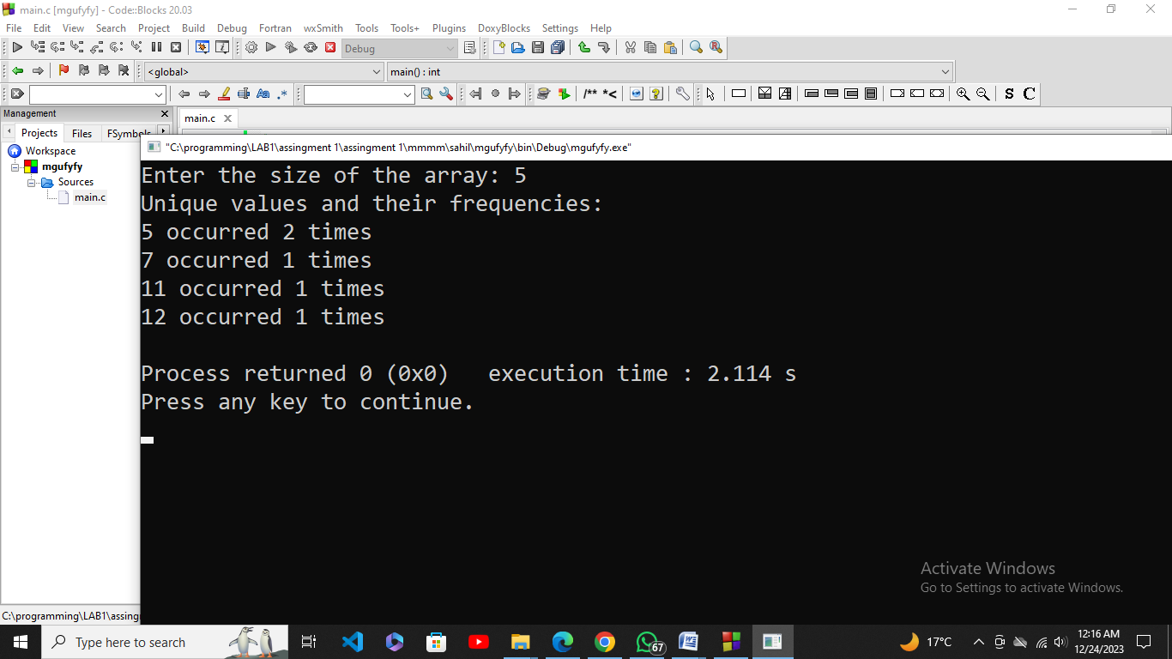

printf("Enter the size of the array: ");

scanf("%d", &size);

int array1[size];

for (int i = 0; i < size; ++i) {

array1[i] = rand() % 20;

}

CountFrequency(array1, size);

return 0;

}

02. Sales flow is one of leading software house they are starting their recruitment process for three different following positions: Associate Developer, Assistant Developer, Trainee Engineer. There is a defined criterion for recruitment process: if candidate clears the test with 50 marks, he will be selected for the post of trainee engineer; experience is not the required for this post. If candidate secures 60 marks with at least one year of experience and 70 marks with at least 2 years of experience, then he/she will be selected as an assistant and associate developer, respectively. Write a function that takes the test marks from user and ask for experience (if the entered marks are x >=60). After that, function shows the assigned position.

#include <stdio.h>

void determinePosition(int marks) {

if (marks >= 50 && marks < 60) {

printf("Congratulations! You have been selected for the position of Trainee Engineer.\n");

} else if (marks >= 60 && marks < 70) {

int experience;

printf("Enter the number of years of experience: ");

scanf("%d", &experience);

if (experience >= 1) {

printf("Congratulations! You have been selected for the position of Assistant Developer.\n");

} else {

printf("Sorry, you do not meet the experience criteria for Assistant Developer.\n");

}

} else if (marks >= 70) {

int experience;

printf("Enter the number of years of experience: ");

scanf("%d", &experience);

if (experience >= 2) {

printf("Congratulations! You have been selected for the position of Associate Developer.\n");

} else {

printf("Sorry, you do not meet the experience criteria for Associate Developer.\n");

}

} else {

printf("Sorry, you did not meet the criteria for any position.\n");

}

}

int main() {

int marks;

printf("Enter your test marks: ");

scanf("%d", &marks);

determinePosition(marks);

return 0;

}

**Out put:**

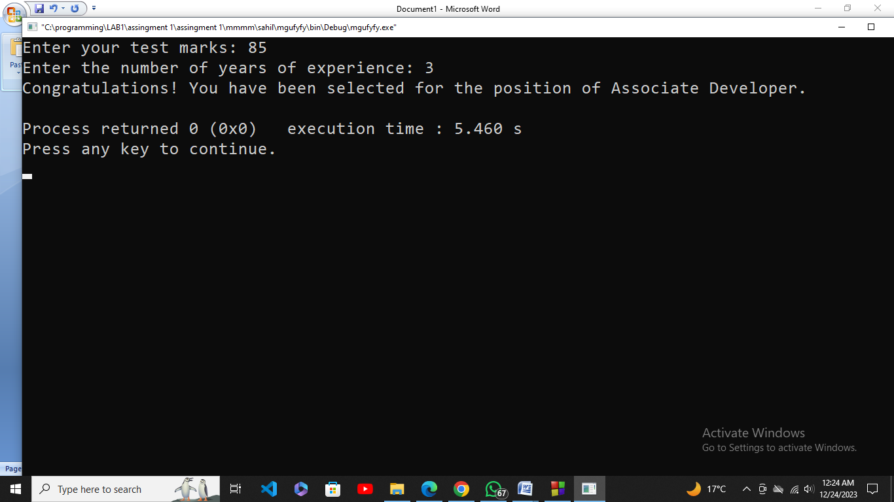

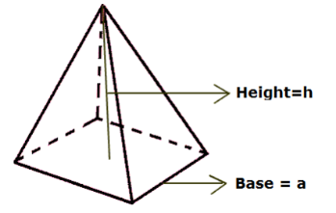03. Write the program that calculate the volume by using following formula

𝑉 = 𝑎 2 ∗ 1 /3 ℎ,

by creating two separate functions. One of the functions with prototype “getData(int h, int a)”, takes two inputs from user. The other function with prototype “volumeCal( )” calculates the volume, and this function must be called from the first function “getData ( )”. The first function must be called from the main function.

#include <stdio.h>

void getData(int *h, int *a);

double volumeCal(int h, int a);

int main() {

int height, sideLength;

getData(&height, &sideLength);

double volume = volumeCal(height, sideLength);

printf("The volume is: %.2f\n", volume);

return 0;

}

void getData(int *h, int *a) {

printf("Enter the height: "); **Out put:**

scanf("%d", h);

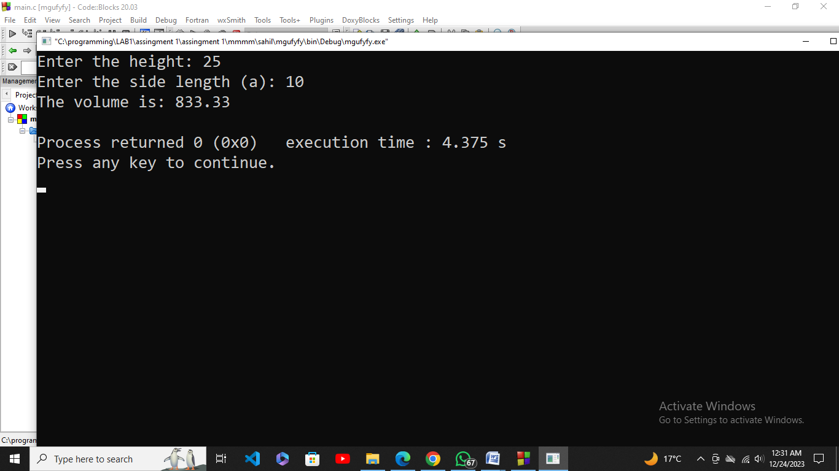

printf("Enter the side length (a): ");

scanf("%d", a);

}

double volumeCal(int h, int a) {

return (a * a * h) / 3.0;

}

04. Write a program that takes a positive number with a fractional part and rounds it to two decimal places. For example, 32.4851 would round to 32.49, and 32.4431 would round to 32.44.

#include <stdio.h>

#include <math.h>

double roundToTwoDecimalPlaces(double num) {

return round(num * 100) / 100.0;

}

int main() {

double inputNumber;

printf("Enter a positive number with a fractional part: ");

scanf("%lf", &inputNumber);

if (inputNumber >= 0) {

double roundedNumber = roundToTwoDecimalPlaces(inputNumber);

printf("Rounded to two decimal places: %.1f\n", roundedNumber);

} else {

printf("Please enter a positive number.\n");

}

return 0;

}

**Out put:**

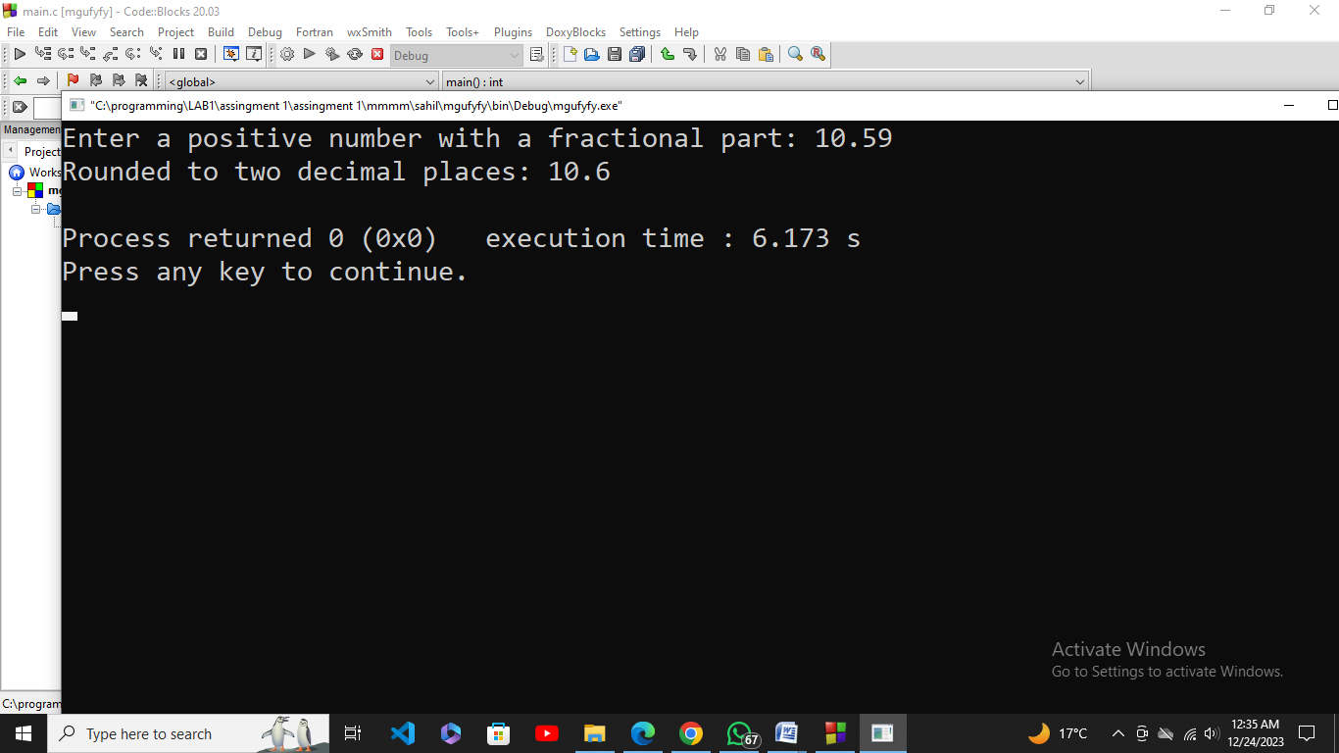

05. In shopping for a new house, you must consider several factors. In this problem the initial cost of the house, the estimated annual fuel costs, and the annual tax rate are available. Write a program that will determine the total cost of a house after a five-year period and run the program for each of the following sets of data.

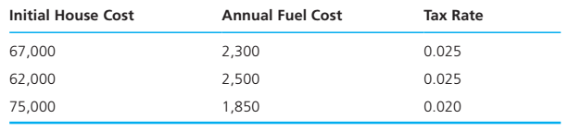  
To calculate the house cost, add the initial cost to the fuel cost for five years, then add the taxes for five years. Taxes for one year are computed by multiplying the tax rate by the initial cost. Write and call a function that displays instructions to the program user.

#include <stdio.h>

void displayInstructions();

int main() {

displayInstructions();

double initialCost, fuelCostPerYear, taxRate;

double dataSets[][3] = {

{150000.0, 1200.0, 0.02},

{200000.0, 1500.0, 0.015},

{180000.0, 1000.0, 0.025}

};

for (int i = 0; i < 3; ++i) {

initialCost = dataSets[i][0];

fuelCostPerYear = dataSets[i][1];

taxRate = dataSets[i][2];

double totalCost = initialCost + (fuelCostPerYear * 5) + (taxRate * initialCost * 5);

printf("Total cost for House %d after 5 years: %.2f\n", i + 1, totalCost);

}

return 0;

}

void displayInstructions() {

printf("Welcome to the House Cost Calculator!\n");

printf("Please input the following data for each house:\n");

printf("- Initial cost of the house\n");

printf("- Estimated annual fuel costs\n");

printf("- Annual tax rate\n");

printf("The program will calculate the total cost of the house after a five-year period.\n\n");

}

Out put:

